Affordable Learning Georgia Textbook Transformation Grants
Final Report
Date:
01/05/2015 – 05/30/2015
Grant Number:
44
Institution Name(s):
Southern Polytechnic State University (SPSU), fall 2014
Kennesaw State University (KSU), spring, 2015
Note: SPSU became Kennesaw State University (KSU) starting from 01/06/2015 due to the SPSU – KSU consolidation.
Team Members (Name, Title, Department, Institutions if different, and email address for each):
Lu Kang, Ph. D.
Assistant Professor (fall, 2014 Semester)
Department of Biology and Chemistry
Southern Polytechnic State University (fall, 2014 Semester)
E-mail: lkang@spsu.edu

Associate Professor (spring, 2015 Semester)
Department of Chemistry and Biochemistry
Kennesaw State University (spring, 2015 Semester)
Email: lkang1@kennesaw.edu

Zhigang Li, Ph. D.
Instruction Technology Specialist
Office of Faculty Support and Development
Southern Polytechnic State University (SPSU), (fall, 2014)
E-mail: zli24@spsu.edu

Instructional Designer
Distance Learning Center
Kennesaw State University (KSU), (spring, 2015)
E-mail: zli8@kennesaw.edu

Project Lead: Lu Kang, Ph. D.
Course Name(s) and Course Numbers: Principle of Chemistry I, CHEM 1211
Semester Project Began: Fall, 2014
Semester of Implementation: Spring, 2015
Average Number of Students Per Course Section: 24 students / section
Number of Course Sections Affected by Implementation: 3 sections (005, 006, 007)
Total Number of Students Affected by Implementation: 70 students

1. List of Resources Used in the Textbook Transformation
Introductory Chemistry, Version 1.0 (ISBN-13: 978-1453-311073)
David W. Ball
http://catalog.flatworldknowledge.com/catalog/editions/ball-introductory-chemistry-1-0
http://catalog.flatworldknowledge.com/catalog/editions/ball-introductory-chemistry-1-0

2. Narrative
A. Describe the key outcomes, whether positive, negative, or interesting, of your project. Include:
- Summary of your transformation experience, including challenges and accomplishments
Being a chemistry instructor who have taught the Principal of Chemistry I (CHEM 1211) for many years, I modified my course instruction materials to teach students very smoothly using the new textbook in the spring 2015 semester. According to our statistics of SPSU student body (2010 – 2014), more than 85% students in the CHEM 1211 classes were non-science majors. Most of them are engineering or technology (E/T) majors who need to learn some chemistry knowledge to fulfill their core course requirements. However, our current CHEM 1211 course design expects students to meet the standards of chemistry majors. For examples, our textbook (Chemistry by Zumdahl) and the final exam (modified from the ACS standard test) are in great favor of chemistry majors. Obviously there is a big gap between the needs of SPSU students and our course materials. How to organize my lectures effectively to take care of the needs of E/T major students while also meet the expectations of CHEM 1211 learning outcome (which is opt for science majors) is a big challenge. In addition to this, to evaluation my teaching using the no-cost textbook, I collected a lot of useful information from in-class student surveys or quizzes, which help me understand the academic background of our current students. This is critical to improve our teaching. From the analyses and the comparison of my data collections, I found a lot of interesting things in teaching CHEM 1211.
In summary, the things that we have done this semester for the ALG project #44 are listed as following:
- Adopted a free downloadable textbook in favor of E/T major students and designed the new course structure based on this book. Students can save ~$200 cost on the book.
- Developed the new class notes (PPT slides) for CHEM 1211 based on the new textbook.
- Redesigned the learning management system, GaView D2L, to upload the instruction materials on-line, which allows students to access these resources conveniently.
- Developed the new problem set questions for students in CHEM 1211 thus they can save ~$40 from using commercial on-line homework system, Sapling Learning.
- Involved three chemistry major students to help me develop problem set questions for this course. This a very good work-study project for those senior chemistry students.
- Revised the pop-up quizzes and recitation questions to meet the need of this course.
- Designed, collected, and analyzed various surveys to evaluate the effectiveness of my teaching using the adopted no-cost textbook.
Finally, the evaluation of my teaching effectiveness in this semester provide me with an opportunity to better understand our students and current teaching environment. This drives me to think about what I can do for improvement in the near future.

- Transformative impacts on your instruction
For a no-cost instruction, I chose the textbook “Introductory Chemistry” by David W. Ball, published by Flatworld Knowledge Inc. in 2014. The pdf version of this book can be downloaded from internet. The instructor has the privilege to get an account from Flatworld Knowledge Inc. to access all the necessary instruction materials, including templates of PPT slides, test banks, quiz questions, and summary of the course contents, etc. I carefully reviewed the contents of this book and found that the goal of author is not to prepare well-rounded chemistry experts but to give a survey of chemistry knowledge for non-science majors. Unlike previous textbooks written for chemistry majors, this book are written in a concise and practical style which can be easily understood by E/T major students. A lot of examples given in this book link chemistry to student’s everyday life, which allow them understand and appreciate the instruction materials. However, some topics that are only important to science majors such as the molecular orbital theory and the quantum theory are only covered superficially in this book. I have to add more details with these topics in the PPT slides. Otherwise, students might get in trouble to meet the expectations of the “Learning Outcome” of CHEM 1211 defined by USG. In addition, to meet the “no-cost” requirement, we stopped to use the on-line homework system (at the cost of ~$40/semester), Sapling Learning. Three chemistry major senior students, Phuong, Chris, and Libbie, joined this project to develop the homework and quiz questions for this course.
To meet the requirement of “no-cost” teaching, we have developed a lot of instruction materials. I would like to keep them because they remain intact to the change of new editions of textbooks. I can post them on the “Learning Management System (LMS), GaView D2L” as auxiliary learning materials even if we change the textbook in the future for some reasons.
In order to better evaluate the teaching effectiveness of this semester, I paid special attention on the academic background of students. I gave them a simple math survey on the first day class to see if they are well prepared for this course. What shocked me the most in this semester was the weakness of math proficiency of our students. Even though CHEM 1211 requires College Algebra (MATH 1111) as its prerequisite, there were still 30% - 40% students cannot answer the question correctly: 1 hour = _______ seconds, and 40% - 50% students cannot answer the question correctly: 2700 seconds = _______ hours. I couldn’t even believe it at the first sight of these results. I asked my colleague, Prof. Zhou, to give the same survey to her classes. Unfortunately, she got the similar results as mine. The details will be discussed in the “Qualitative and Quantitative Measures” on this report. This unexpected result drove me to modify the instruction materials and made great efforts to integrate basic math knowledge into my lecture and recitation classes.
- Transformative impacts on your students and their performance
Most students like the idea to use no-cost textbook and homework. They can save $200 - $300 in my class comparing to other students. The book I chose is much easier to read than the textbook written for science majors. Since more than 85% SPSU students are E/T majors, most students would like to use no-cost book based on my survey. As aforementioned, the new textbook omit some topics that are unimportant to E/T majors, such as quantum theory and molecular orbital theory. But they are required by the learning objectives of CHEM 1211. Thus I developed the PPT slides to cover them in my class notes and post them on the D2L. What surprised me was that many students are “active learners”. If they cannot find something from the book they will search the on-line videos to learn this topic. Interestingly, I found from student survey that a significant portion of students (at least 25%) do not read the book at all even though the book can be free downloadable from internet. According to my survey results, less than 10% students claim that the textbook as their most important learning resource. On the contrary, 35.4% and 25% students prefer to use PPT slides (class notes) and on-line videos as their major learning resources. Both of them are on-line accessible and internet based technology. It seems that the textbook is playing a less and less important role in student learning than before.
I taught the same course in fall 2014 using the old textbook. The student performance of CHEM 1211 students in the spring 2015 semester is not as good as the previous semester. But the spring semester to the CHEM 1211 students is the “off-sequence” semester, usually the student performance in an “off-sequence” semester is significantly worse than the “in-sequence” semester because only students who cannot keep up the pace will take the “off-sequence” course, e.g., taking CHEM 1211 in the spring semester. The same trend is also reflected by our CHEM 1211 Lab. The SPSU chemistry program give the uniform lab practical test to all students. The average grade for spring 2015 semester students is 68% while the fall 2014 semester students gave an average grade of 78%. Given the large sample sizes of more than 300 students in each semester, there is still a 10% gap between them. Thus there is an obvious difference between the academic background of “in-sequence” and “off-sequence” students. To be fair, I compared the hour exam test results with my colleagues who use the old textbook. There is no significant difference between each other. In fact, the traditional textbook is no longer dominate learning resource for students. According to my survey, more than 60% students prefer to use on-line based resources to study. The traditional textbook is no longer an limiting issue for student learning.

B. Describe lessons learned, including any things you would do differently next time.
Based on my transformative experience in the spring 2015 semester, I would like to improve my teaching of CHEM 1211 with the following things:
- Given the extremely weak math proficiency of our student, I would spend more time and give more practices in the class to introduce fundamental math concepts and skills. Otherwise, they cannot do anything seriously in science without adequate math literacy.
- The prevalent academic resources on the internet make me realize that being a faculty member, it is time to change my role from a lecture instructor to a student learning organizer. I should encourage student to conduct active learning outside of the traditional classes instead of bring their ears to the classroom. I should reorganize my course materials to incorporate more on-line resources and give them to students.

3. Quotes
- Provide three quotes from students evaluating their experience with the no-cost learning materials.
- “Yeah, I really like the idea to use free textbooks. The textbooks are too expensive!”
2. “I did read the book but sometime I also read other books and look at on-line videos. I can get almost everything I want on-line.”
3. “Absolutely, the textbooks are too expensive. Thank you to let us use free ebook.”

4. Quantitative and Qualitative Measures
  - Drop, fail, withdraw (DFW) delta rates
DFW rate = 39/70 = 55.71%
  - Course retention and completion rates
Course retention rate, 1st week survey: 66/70 = 94.29%
Course retention rate, 1st Hour Exam: 60/70 = 85.71%
Course retention rate, 2nd Hour Exam: 56/70 = 80.00%
Course retention rate, 3rd Hour Exam: 50/70 = 71.43%
Course retention rate, 4th Hour Exam: 46/70 = 65.71%
Course completion rate, Final Exam: 48/70 = 68.57%
  - Average GPA
Average GPA = 1.52
A: 5
B: 13
C: 13
D: 9
F: 22
W: 8

Note:
The Low GPA is mainly because of the high DFW rate. Many students took this course but seldom show up in the class. For example, ~43% (30 out of 70) students missed more than 20% class meetings (9 class hours). Interestingly, they don’t quit the course (in order to keep their full time student status to be eligible to get the student loan). Thus there are so many F’s in this course.

  - Pre-and post-transformation DFW comparison
Pre-transformation DFW rate Post-transformation DFW rate
Fall, 2014 semester: 41.67% Spring, 2015 semester: 55.71%
Note:
The spring semester for CHEM 1211 is an “off-sequence” semester. The DFW rate is usually worse than that of “in-sequence” (fall) semester. Since I didn’t teach CHEM 1211 in the spring semester in the past five years. I can’t tell how bad the CHEM 1211 DFW rates in the spring semester compared to that of fall semesters. But the average grades of CHEM 1211 Lab Practical Tests (for ~300 students/each semester) and the average grades of CHEM 1211 lecture classes agree with each other quite well. They can be used as the side proofs because both the CHEM 1211 lab practical test and the CHEM 1211 final exam are the uniform tests to all SPSU chemistry students.
Fall, 2014 Lab Practical Test: 78% Spring, 2015 Lab Practical Test: 68%
Fall, 2014 CHEM 1211 Final: 74% Spring, 2015 CHEM 1211 Final: 64%

  - Student success in learning objectives
The Faculty Assessment Report Card results are tabulated as following
Criterion for Success: 65% of students can answer 3 out of 5 questions correctly
Learning Outcome | Method | % Met  Fall 2014 | % Met  Spr. 2015
- Understand the general properties of matter, dimensional analysis, units, and significant figures. | Final Exam  #1-5 | 88.6% | 72.9%
- Name and classify inorganic compounds. | Final Exam #6-10 | 91.4% | 77.1%
- Understand and use mole concept and mass/mole relationships. | Final Exam #11-15 | 82.9% | 75.0%
- Can balance chemical equations. | Final Exam Essay #1-5 | 94.3% | 77.1%
- Identify different types of reactions and predict products. | Final Exam #16-20 | 40.0% | 56.2%
- Apply solution concentration and solution reactions to mole-mass relationships. | Final Exam #21-25 | 54.3% | 52.1%
- Apply gas laws and kinetic theory to gases. | Final Exam #26-30 | 71.4% | 54.2%
- Understand and apply First Law of Thermodynamics. Lattice energy, average covalent bond energy. | Final Exam #31-35 | 54.3% | 45.8%
- Understand basic concepts of quantum mechanics; determine electron configurations, periodic trends, and atomic properties. | Final Exam #36-40 | 77.1% | 77.1%
- Use Lewis Structures, determine molecular geometry, and learn bonding theory including hybridization. | Final Exam #41-45 | 65.7% | 58.3%

  - Surveys, interviews, and other qualitative measures
- Math proficiency survey given to the students on the 1st week of spring 2015 semester.
Math Survey Questions | Answer | Correct answer rate  Kang class, 66 studs. | Correct answer rate  Zhou class, 60 studs.
- (10)⁰ = __________ | 1 | 40 / 66 = 60.61% | 50 / 60 = 83.33%
- Express your answer in exponential notation:  0.0000001 = __________ | 10⁻⁷ | 40 / 66 = 60.61% | 39 / 60 = 65.00%
- Express your answer in a fractional number:  (3)⁻³ = _________ | 1/27 | 22 / 66 = 33.33% | 26 / 60 = 43.33%
- 3² × 2³ = _________ | 72 | 56 / 66 = 84.85% | 41 / 60 = 68.33%
- Express your answer in a fractional number:  2/3 + 3/5 = _________ | 19/15 | 56 / 66 = 84.85% | 50 / 60 = 83.33%
- Solve the equation:  (x)^{2/3} = 9 | x = +27  or -27 | 15 / 66 = 22.73% | 20 / 60 = 33.33%
- Solve the equation:  3x + 2 = 5x - 7 | x = 4.5 | 47 / 66 = 71.21% | 51 / 60 = 85.00%
- Solve the equation:  x² + x - 12 = 0 | x₁ = 3  x₂ = -4 | 31 / 66 = 46.97% | 32 / 60 = 53.33%
- 1 hour = ________ seconds | 3600 | 46 / 66 = 69.70% | 41 / 60 = 68.33%
- 2700 seconds = _______ hour | 0.75 | 36 / 66 = 54.55% | 29 / 60 = 48.33%
Overall Results |  | 389 / 660 = 58.94% | 379 / 600 = 63.17%

I was really shocked by these results! Among the 126 students from my class and Dr. Zhou’s class who took the survey on the first week of spring 2015 semester:
- 20% - 25% students cannot solve the simple linear equation, 3x + 2 = 5x -7, correctly.
- 50% students cannot solve the simple quadratic equation, x² + x - 12 = 0.
- More than 30% students do not know that 1 hour should equal 3600 seconds.
- More than 50% students do not know that 2700 seconds equal how many hours.
All students enrolled in our classes should pass the College Algebra (MATH 1111), a perquisite for CHEM 1211. College students should have learned that 1 hour = 60 minutes and 1 minute = 60 seconds. If they still cannot figure out the answers of questions 9 and 10 in my survey, it implies that those students do not understand the meaning of multiplication and division. They probably know how to push the buttons of a calculator to do some calculations, but they cannot “think” and do not understand the meaning of mathematic operations. In a word, large percentage (30% - 50%) of students in our classes do not have the necessary “problem solving skills” to survive their STEM education in the college.
- Anonymous survey of the use of our (no-cost) textbook
I gave 4 survey questions at the end of semester to learn about the use of our adopted textbook. I collected 41 effective answers from students in my class. The results are given as following:
Question 1:
Do you think that the textbook, “Introductory Chemistry, 1st Ed., by David W. Ball”, helps you understand the course materials in CHEM 1211?
- Absolutely agree. It is extremely useful in this course.
- Strongly agree. It is useful in this course.
- Moderately agree. It is useful for me to understand some concepts.
- Disagree. I only read the textbook occasionally, not so much useful.
- Totally disagree. It is useless and I don’t read this textbook at all.
For this question, 3 students (7.32%) chose A, 5 students (12.20%) chose B, 21 students (51.22%) chose C, 6 students (14.63%) chose D, and 5 students (12.20%) chose E. If using a 5 point scale (set A = 5, B = 4, ⋅⋅⋅, E = 1) to evaluate this book, the score is 2.93.
Question 2:
Which one of the following helps you the most in learning the CHEM 1211 this semester?
- Textbook
- PPT slides
- Lecture and/or recitation classes
- On-line video
- Problem set questions
For this question, some students chose multiple answers. Thus there are 48 answers from 41 students who took the survey. Among them, 3 votes to A (6.25%), 17 votes to B (35.42%), 7 votes to C (14.58%), 12 votes to D (25.00%), and 9 votes to E (18.75%). The answers A, C, and E are traditional way of learning, while the answers B and D are web based learning resources. Interestingly, more than 60% (29/48) votes were given to the non-traditional ways of learning. This is a trend that worth our consideration in the preparation of learning materials for future students. It seems that the traditional textbook is no longer the most important resource for student learning.
Question 3:
Do you own the textbook – “Introductory Chemistry, 1st Ed., by David W. Ball”?
- Yes, I purchased a hardcopy of this textbook.
- Yes, I downloaded an electronic version of this textbook for free.
- Yes or no. I have the required textbook but I mainly read other chemistry textbooks for study.
- No, I don’t like this book and I don’t read it.
For this question, 2 As, 30 Bs, 5 Cs, and 4 Ds were given by students as their answers. It seems that most students would like to take the advantage of using free resource. However, there are still 22% students do not appreciate this free textbook and use other materials for their study.
Question 4:
Do you think that using the on-line free resources (such as free downloadable textbooks) is a good idea in teaching this course?
- Yes, the textbooks from those major publishers are too expensive!
- No, I don’t read textbooks very often whether or not I do have them. I prefer to read class nots (PPT slides) or watch free on-line videos to learn the knowledge.
For this question, 75% students chose A as their answers. The cost of textbook is obviously a major concern of our students. Interestingly, there are still 25% students do not like to use textbook even if it is free accessible. Probably they prefer to study in a non-traditional way.
- Textbook Evaluation:
I downloaded a textbook evaluation form from the “Crystal Springs Books” website to evaluate our textbook. This reproducible form can be found from the following link: http://www.sde.com/downloads/teacherresources/di_text/textbook_evaluation.pdf
This form uses a 1 (poor) – 4 (excellent) scale system to evaluate the book quantitatively in 18 categories. I give it to students as an anonymous survey. It is very lengthy and some students wouldn’t bother to answer it (it is more likely that some of them rarely read the book). I only collected 37 effective answers from my class. The results are summarized in the following table:
Book Title: Introductory Chemistry, Version 1 | Ratings
Author(s): David W. Ball Publisher: Flatworld Knowledge Inc. | 1 – 4
Table of Contents:  Materials is presented in an order that makes sense for teaching. | 2.76
Glossary:  Unfamiliar/specialized terms are well-defined and their pronunciations are included. | 2.86
Bibliography:  List of books and other reference works used by author(s) is comprehensive and up to date | 2.71
Web Sites:  Include direct links to pertinent information. | 2.47
Index:  Index is thorough and easy to use, and consists of entries that are detailed and cross-referenced. | 2.44
Writing Style:  Writing is descriptive and thought-provoking, and fosters visualization, sparking the reader’s imagination on many levels. Vocabulary consists of words that are both familiar and challenging, and words the reader may not know are clearly defined. Main ideas are explicit, not imbedded in the text. | 2.76
Headings/Subheadings:  Headings and subheadings support the content and preview what is coming so that the reader get a clear idea about the section and can make predictions and read for purpose – helpful with before-reading activities. Wording is explicit rather than vague or ambiguous. | 2.81
Captions and labels:  Captions and labels are accurate and informative, and supplement the text or main ideas in that part of the book. | 2.92
Sidebars:  Sidebars augment the text by highlighting incidental or little-known information, or by expanding upon points or ideas mentioned in the text. | 2.57
Topics sentences and section/chapter previews:  These communicate what is being discussed/developed in the paragraph or section/chapter; allow the reader to establish, identify, and absorb main ideas; and provide helpful information for before-reading activities. | 2.81
Section/Chapter summaries:  Key ideas and main points supporting the topic discussed in the section/chapter are clear and accurately restated. | 3.03
Extension activities:  Includes relevant activities offering sufficient practice so that the student can reinforce and retain what has been taught. Activities focus on different ways in which students might continue their study based on various learning styles. | 2.89
Page layout:  The text is complemented/supported by graphic elements | 2.76
End-of-Section/Chapter Comprehension and Critical-Thinking Questions:  The questions make connections between the learned content, allow the reader to reflect on main ideas, and extend critical thinking about past and future events. Questions also are multi-leveled, i.e., there are questions that the reader can answer by looking in a specific place to find the answer, and others that require the reader to look for clues in what they have read and combing there with their prior knowledge. The number of questions included provides ample practice for students. | 2.97
Type style, line length, and leading:  The point size of the type, length of the line of type, and space between each line all work together, producing a page that is not only visually appealing but also readable and accessible. | 2.65
Graphic element (Photographs, illustrations, maps, charts, etc.)  Graphics are consistently identified with call outs, such as Figure-1, Figure-2, etc. | 2.91
Maps and charts includes a caption that succinctly identifies it and makes a direct connection between it and the text. | 2.94
At least half of the graphics are in color. | 3.12
Grand average (out of 4 point scale) | 2.80/4

5. Sustainability Plan
CHEM 1211 is one of the most popular science core course for college students. We are going to offer this course every semester thus the maintenance and updating of course materials are the necessary things for us to do. For KSU students, they can access the course materials through D2L. I will try to post the link of the textbook and the PPT slides on my personal website so that other students can downloaded the course materials. Due to the consolidation of SPSU and KSU, we are not sure if we can get a public site to post our course materials. We have to wait until this fall semester. Currently, my personal faculty website will be best choice to upload the course materials.
6. Future Plans
Given the very weak academic background of our students, most chemistry textbooks opt for science majors are too hard for them. It will be a wise idea to choose a textbook that can be understandable by those students. Fortunately, the free textbook we chose allows us to modify the book at our own will. I plan to integrate more math and problem solving skill training materials into it. In addition, this book omits molecular orbital theory and some part of the quantum theory that are required by the learning outcomes of CHEM 1211. I will write some supplement content to make up these course instruction materials.
The next thing we would like to do is to develop a question pool and use it to generate appropriate problem set and quiz questions to our students. Three chemistry major students did some preliminary work with me this semester. We will continue this work in the next few years.
If possible, we will like to extend our work to the Principle of Chemistry II, CHEM 1212.
There is an annual conference at Kennesaw State University (KSU) about higher education organized by USG. We would like to give a presentation in the conference next year based on the data we collected this spring semester. We are also working on the analysis of our data collections in the past five years about chemistry core courses (CHEM 1211, CHEM 1212). Probably we can publish a paper based on our work.
7. Description of Photograph
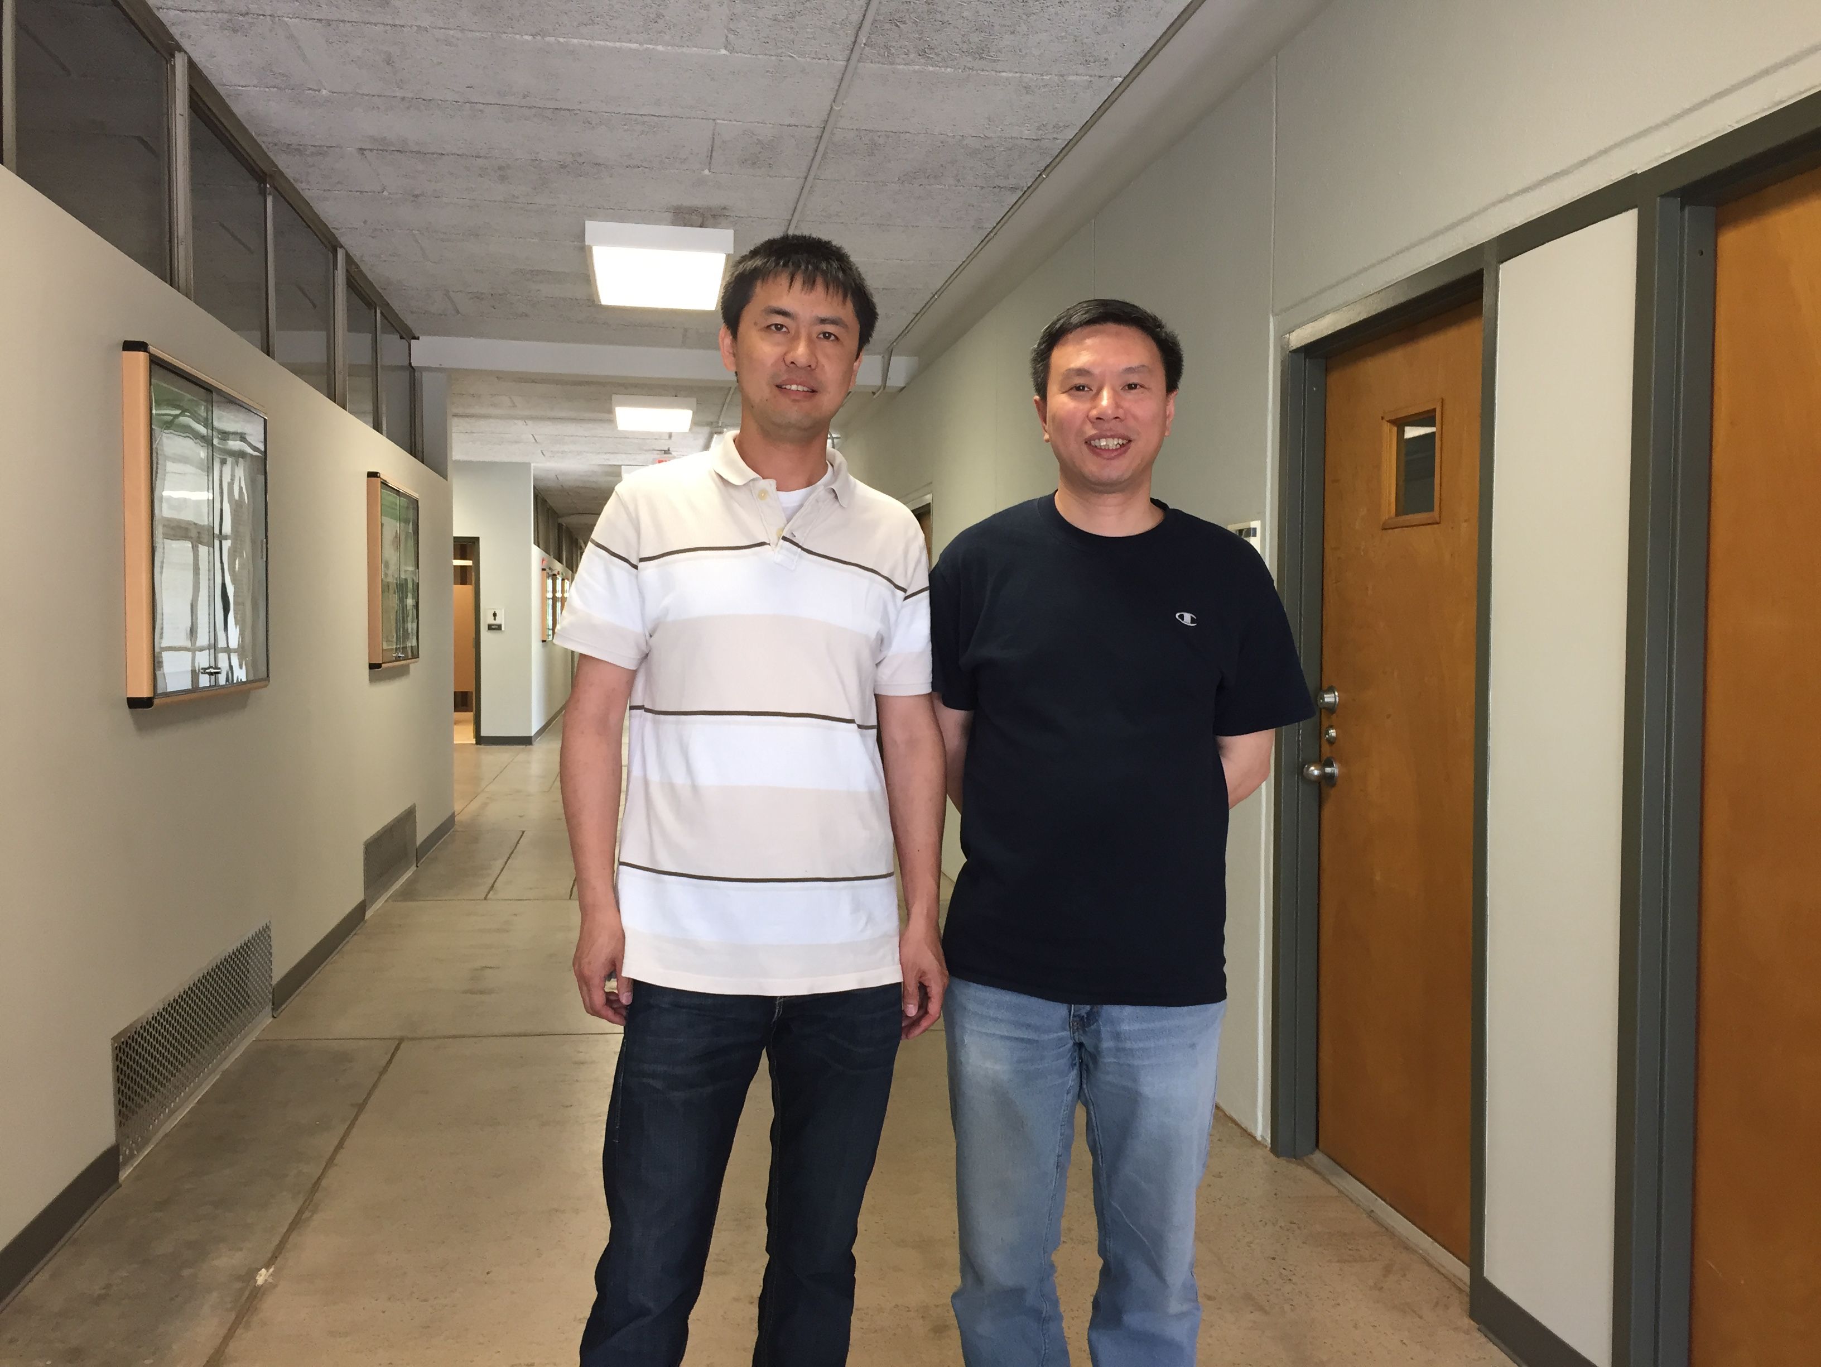

From left to right:
Dr. Zhigang Li, Instructional Designer, Co-PI; Dr. Lu Kang, Associate Professor, team lead, PI.

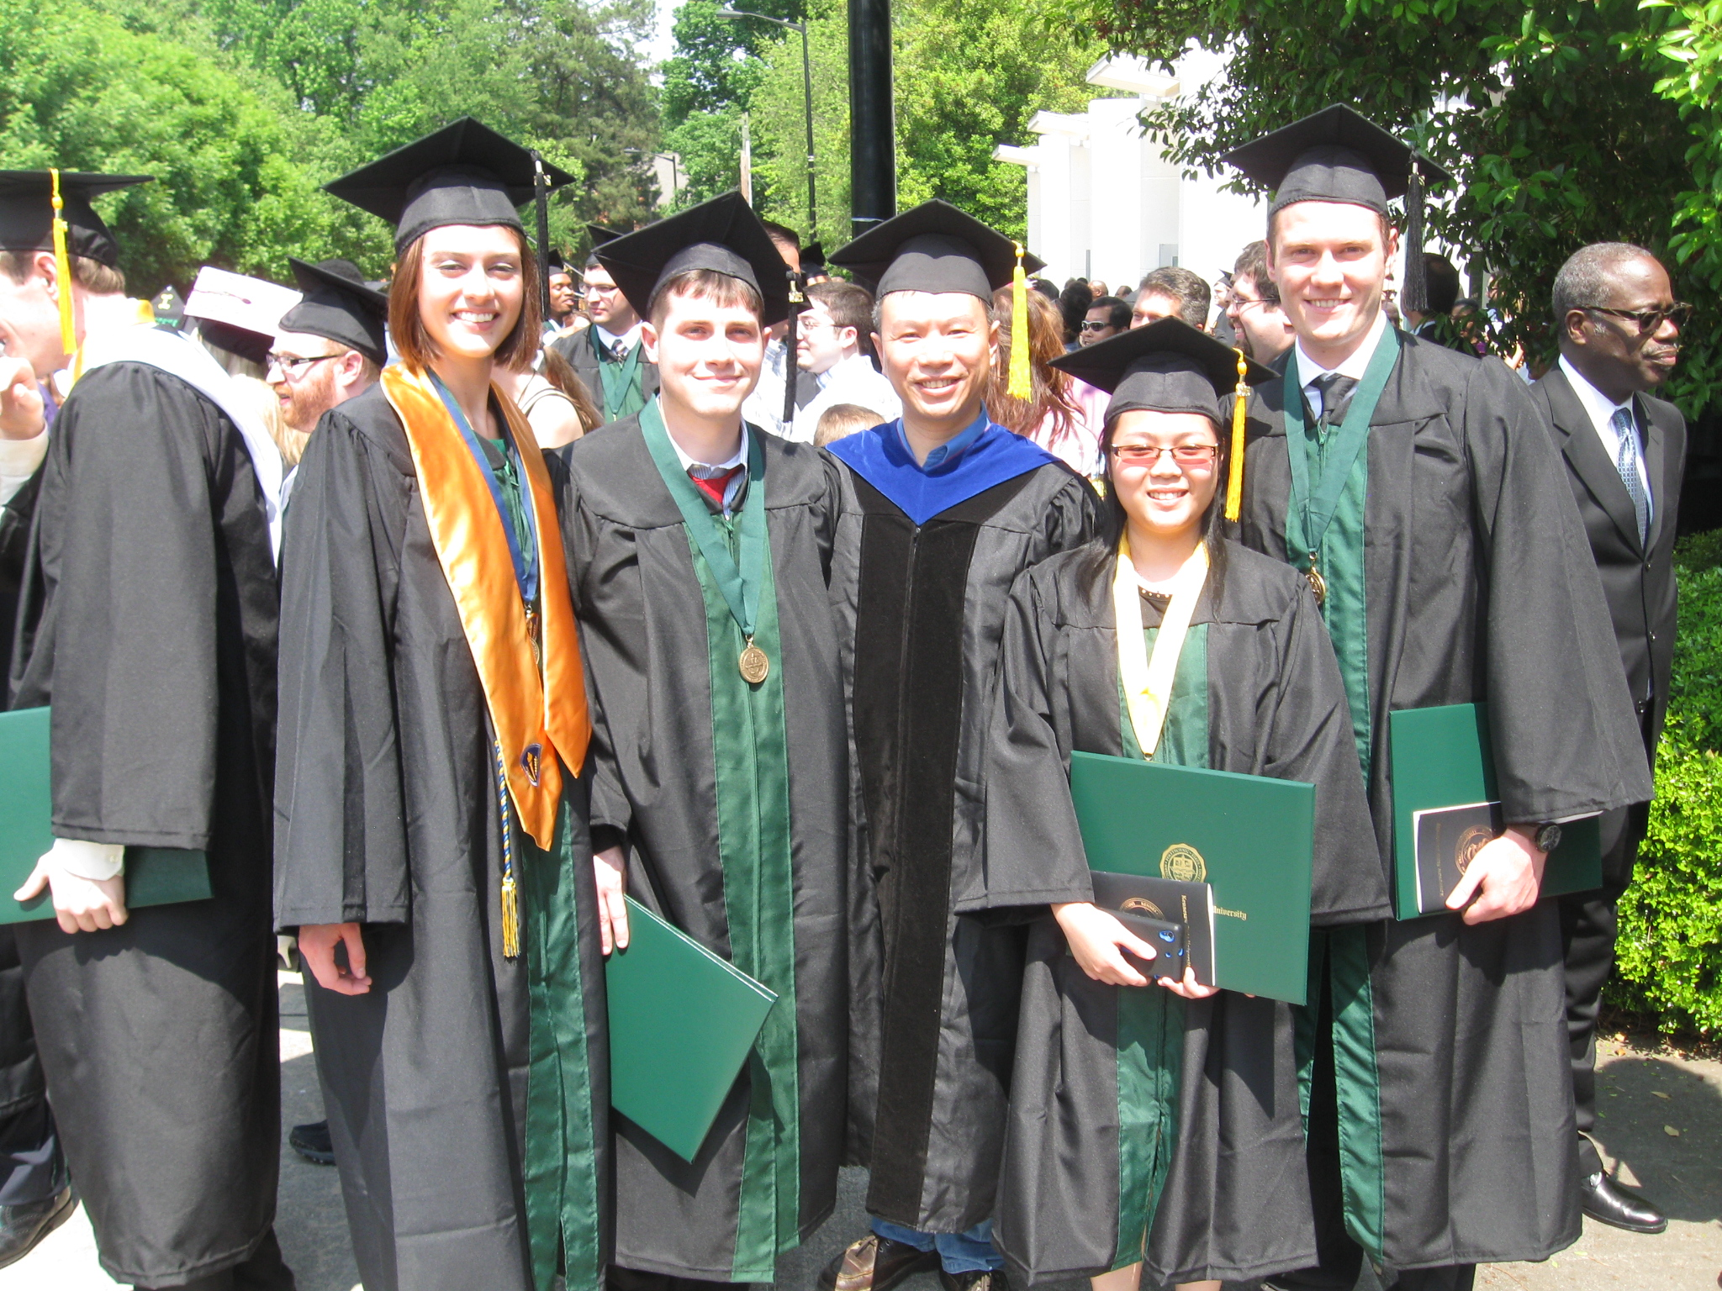

From left to right:
Ms. Elizabeth M. McCullen, B. S., senior chemistry major Work-Study student for this project;
Mr. Christopher M. Baratz, B. S., senior chemistry major Work-Study student for this project;
Dr. Lu Kang, Associate Professor, team lead, PI for this project;
Ms. Phuong H. Pham, B. S., senior chemistry major Work-Study student for this project;
Mr. James A. Thornhill, B. S., senior chemistry major student who gave us comments.

